WORDSNAKE EXERCISE

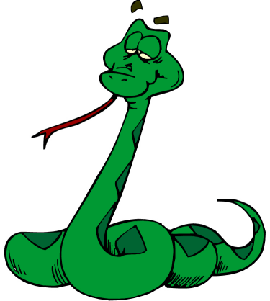

Retype the following text inserting the spaces where appropriate

Lady Gaga - Early life and education
BornonMarch28,1986,inYonkers,NewYork,theeldestchildofItalianAmericanparentsJosephandCynthiaGermanotta,atage11shewassettojoinJuilliardSchoolinManhattan,butinsteadattendedConventoftheSacredHeart,aprivateRomanCatholicschool.Playingpianobyearfromtheageof4,shewentontowriteherfirstpianoballadat13andbeganperformingatopenmikenightsbyage14.Atage17,shegainedearlyadmissiontotheNewYorkUniversity'sTischSchooloftheArts.There,shestudiedmusicandimprovedhersongwritingskillsbycomposingessaysandanalyticalpapersfocusingontopicssuchasart,religionandsocio-politicalorder.Shelaterwithdrewfromtheschooltofocusonhermusicalcareer.

